Free FLV Converter 5.81
Features
License: Free
Editor's Rating: 4.0 stars
Average User Rating: 3.0 stars (out of 115 votes)
Downloads: 809,571
Operating Systems: Windows Vista, Windows XP, Windows 2000
Additional Requirements: Windows 2000/XP/2003 Server/Vista
Limitations: No limitations
Date Added: October 31, 2008

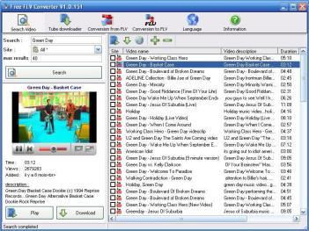
Get your favorite online videos easier than ever with this free software. You will be able to search videos without opening your browser and watch them using the built-in video player. This freeware can convert FLV files to AVI, iPod (MPEG4 or H.264), iPhone, 3GP, PSP, or MP3 audio only. Supported Web sites: YouTube, DailyMotion, Google Videos, Metacafe, Spike, iFilm, Veoh, Yahoo, Crackle, Broadcaster, ZippyVideos, MySpace, Revver, LiveLeak, EyeSpot, CollegeHumor, SevenLoad, Break, CrunchyRoll, Blip.tv, lulu.tv, archive.org, TinyPic, EbaumsWorld, Uncut AOL, Guba, Youku, Tudou, Reuters, BBC News, vh1. This software can also convert all your videos (DivX, XviD, MpeG, DVD, AVI) to FLV video (Flash video) with an automatic HTML page creation. You will only have to place the files on your website to share your videos with the entire world.
Version 5.81 adds new Web sites in the list and corrects some of them and improves video conversion.

