Riva FLV Encoder 2
Features
License: Free
Editor's Rating: 4.0 stars
Average User Rating: 3.0 stars (out of 130 votes)
Downloads: 4,763,389
Operating Systems: Windows Me, Windows XP, Windows 2000, Windows NT, Windows 98
Additional Requirements: Windows 98/Me/NT/2000/XP
Limitations: No limitations
Date Added: April 13, 2005

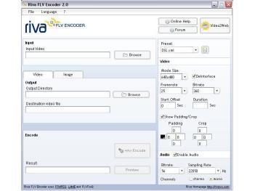
Riva FLV Encoder enables you to encode video files to Flash video (.FLV) files. It currently supports the most common video formats, including AVI, DV, MPEG, MOV, and WMV, and includes a player to preview the converted .FLV file. The program supports custom output settings and allows you to save your configuration as profile for easy access. Version 2.0 includes FLV 1.1, cropping, and padding.

